1. library(ggplot2)
data <- data.frame(
week = rep(c('2023-01-01','2023-01-08','2023-01-15'), each=3),
city = rep(c('New York','Los Angeles','Chicago'), 3),
temp = c(-2,15,-5,0,17,-3,2,18,-2)
)
ggplot(data, aes(week, temp, color=city, group=city)) +
geom_line() + geom_point() +
labs(title="Weekly Temperature Comparison",
x="Week", y="Avg Temp (°C)")
output:
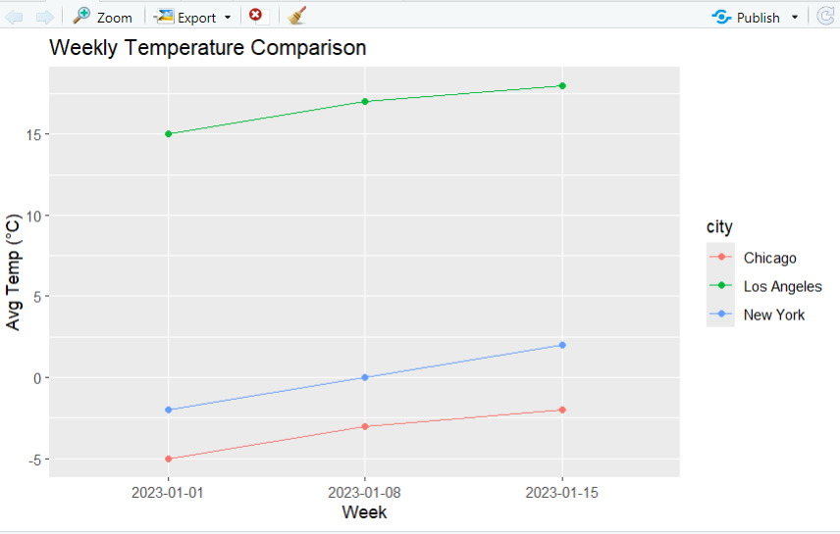
2.
repeat {
cat("\nMenu:\n")
cat("1. Option 1\n")
cat("2. Option 2\n")
cat("3. Option 3\n")
cat("0. Exit\n")
selection <- readline(prompt="Enter an item from the menu, or 0 to exit: ")
if (selection == "0") {
cat("Exiting the program. Goodbye!\n")
break
} else if (selection == "1") {
cat("You selected Option 1\n")
} else if (selection == "2") {
cat("You selected Option 2\n")
} else if (selection == "3") {
cat("You selected Option 3\n")
} else {
cat("Invalid selection, please try again.\n")
}
}
Output:
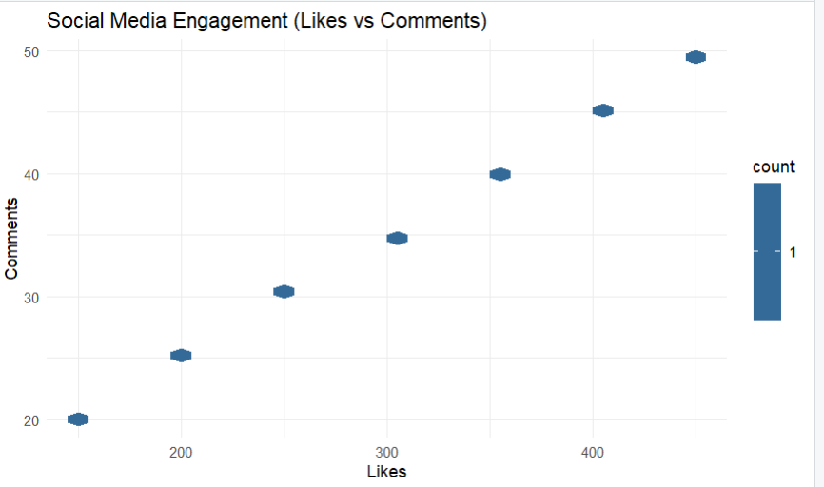
3.
library(ggplot2)
sales <- data.frame(
Month = c('Jan','Feb','Mar','Apr','May','Jun','Jul','Aug','Sep','Oct','Nov'),
A = c(500,600,700,800,750,850,900,950,1000,1050,1100),
B = c(300,320,350,400,420,450,480,500,550,580,600),
C = c(200,250,300,350,400,420,450,470,500,530,550)
)
# Convert to long format manually
sales_long <- data.frame(
Product = rep(c("A","B","C"), each = nrow(sales)),
Sales = c(sales$A, sales$B, sales$C)
)
ggplot(sales_long, aes(Product, Sales, fill = Product)) +
geom_violin(trim = FALSE) +
geom_jitter(width = 0.1, size = 1) +
theme_minimal()

output:
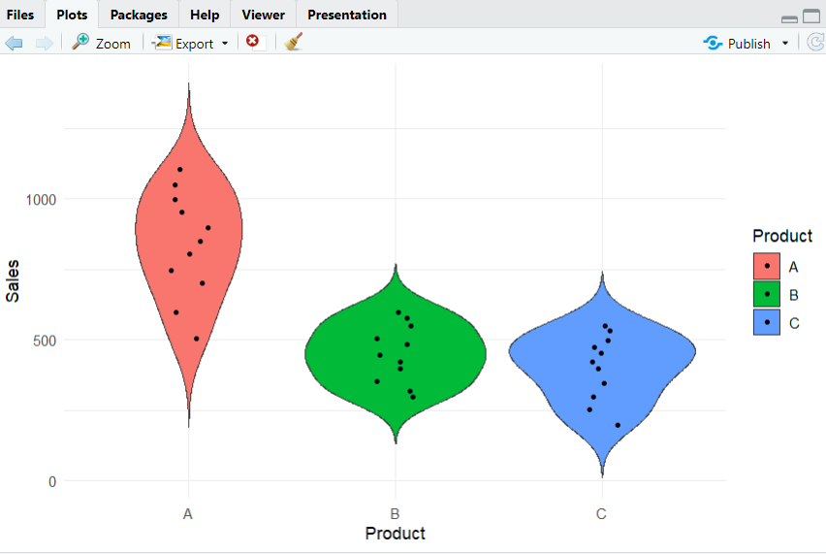
4.
library(ggplot2)
survey <- data.frame(
Category = c("Product Quality","Customer Service","Value for Money"),
Very_Dissatisfied = c(5,10,8),
Dissatisfied = c(15,20,12),
Neutral = c(25,30,28),
Satisfied = c(35,25,32),
Very_Satisfied = c(20,15,20)
)
survey_long <- data.frame(
Category = rep(survey$Category, 5),
Rating = rep(c("Very Dissatisfied","Dissatisfied","Neutral","Satisfied","Very Satisfied"), each=3),
Count = c(survey$Very_Dissatisfied, survey$Dissatisfied, survey$Neutral, survey$Satisfied, survey$Very_Satisfied)
)
ggplot(survey_long, aes(Category, Count, fill=Rating)) + geom_bar(stat="identity") + theme_minimal()
output:
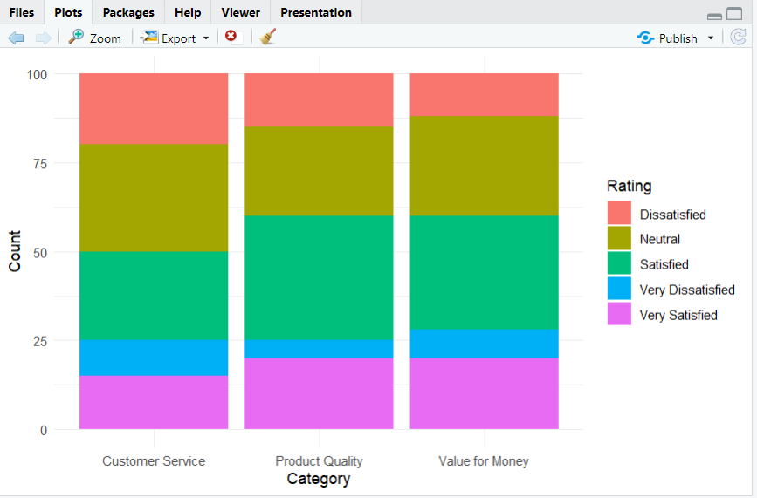
5. library(ggplot2)
performance <- data.frame(
Employee = c('A','B','C','A','B','C','A','B','C'),
Score = c(85,90,78,88,92,80,90,94,82)
)
ggplot(performance, aes(x=Score, fill=Employee)) +
geom_histogram(position="dodge", binwidth=5, color="black") +
theme_minimal()
output:
